**Assignment-3 Data Warehousing and Analytics in the cloud**

**Q1. Show the screenshot of a successful installation of MySQL Software and MySQL Workbench with the latest version on your machine. Show the screenshot of the database “Worker” created.**

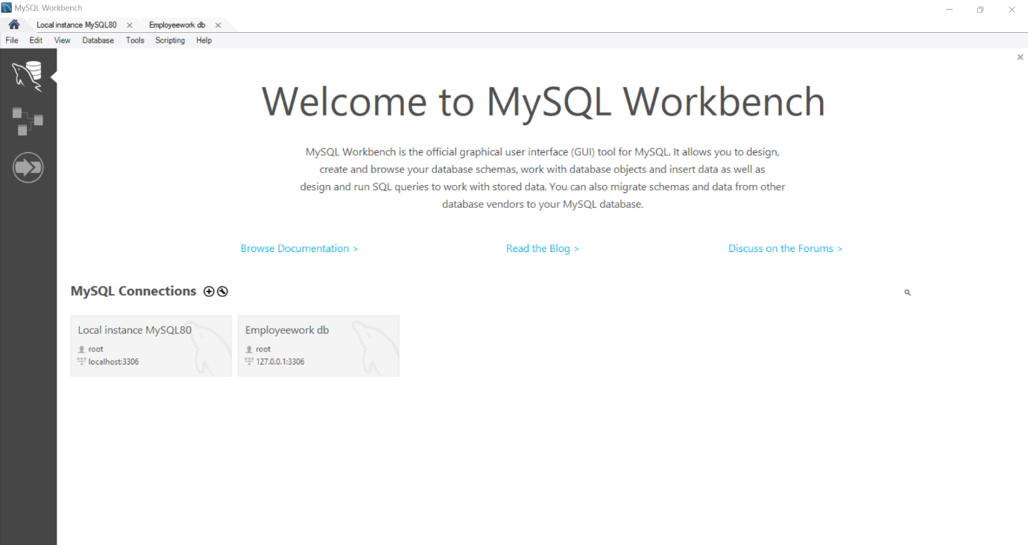

Since I have already MySQL installed in my computer. I have attached the screenshot of the Homepage of MySQL Workbench.

I have created a connection as “Employeework db”.

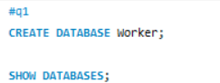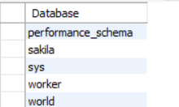

Created a database “worker” and as it is displayed in the list of databases that are available.

**Q2. Create the Department table in the Worker database (table must be based on Physical Model Provided in the Assignment folder). (a) Columns, Primary Key (PK), Data Type & length, and NULL/NOT NULL need to be implemented, as provided in the Physical Model. (b) Show the table definition (DDL) that you implemented. (c) Insert the complete set of data provided in the Excel file (uploaded in the Assignment folder) and show the insert statements used. (d) Retrieve the data from the Department table by using the SELECT * statement and order by PK column(s). Show the output. Make sure you show the print screen of the complete set of the rows and columns. The rows must be ordered by PK column(s).**

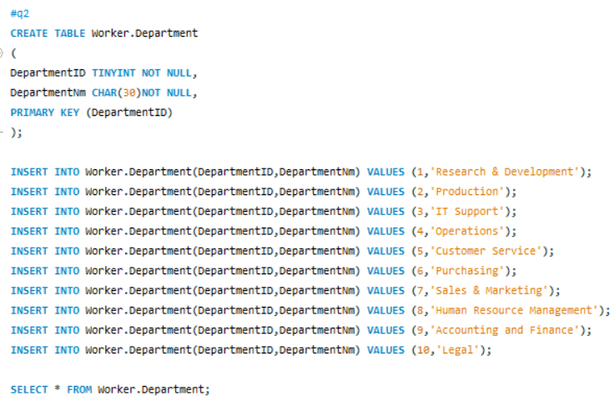

As you can see above created a table with DepartmentID and DepartmentNm which are available in the specific organisation

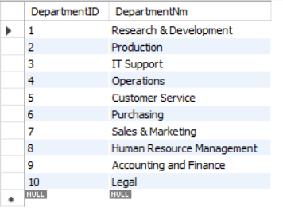

From the above code the table is displayed as above.

**Q3. Create the Employee table in the Worker database (table must be based on Physical Model Provided in the Assignment folder). (a) Columns, Primary Key (PK), Data Type and length, and NULL/NOT NULL need to be implemented, as provided in the Physical Model. (b) Show the table definition (DDL) that you implemented (not in a graphical view). (c) Insert the complete set of data provided in the Excel file (uploaded in the Assignment folder) and show the insert statements used. (d) Retrieve the data from the Employee table by using the SELECT * statement and order by PK column(s). Show the output. Make sure you show the print screen of the complete set of the rows and columns. The rows must be ordered by PK column(s).**

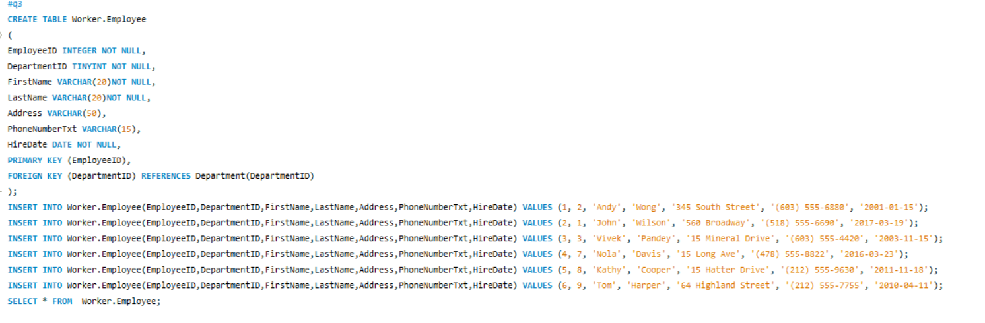

As you can see the we are creating the table with the Employee details such as employee id, first name, last name, address etc.. and filling all the details

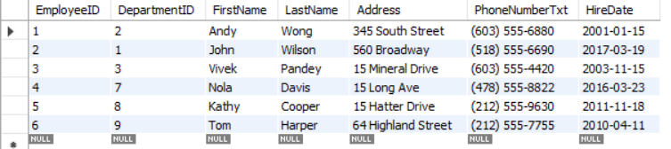

From the above code the employee table is displayed above

**Q4. Create the Equipment table in the Worker database (table must be based on Physical Model Provided in the Assignment folder). (a) Columns, Primary Key (PK), Data Type & length, and NULL/NOT NULL need to be implemented, as provided in the Physical Model. (b) Show the table definition (DDL) that you implemented. (c) Insert the complete set of data provided in the Excel file (uploaded in the Assignment folder) and show the insert statements used. (d) Retrieve the data from the Equipment table by using the SELECT * statement and order by PK column(s). Show the output. Make sure you show the print screen of the complete set of the rows and columns. The rows must be ordered by PK column(s).**

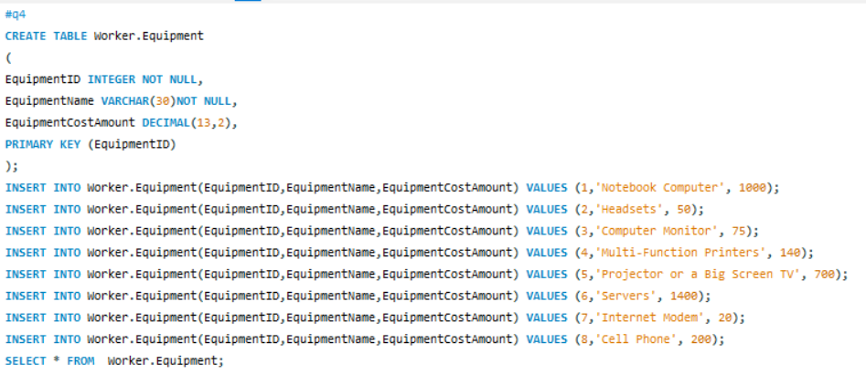

As you can see, we have created a table for the equipment with the equipment id, name and cost.

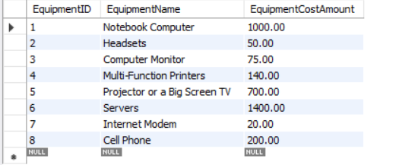

From the above code the equipment table is displayed.

**Q5. Create the EmployeeEquipment table in the Worker database (table must be based on Physical Model Provided in the Assignment folder). (a) Columns, Primary Key (PK), Data Type & length, and NULL/NOT NULL need to be implemented, as provided in the Physical Model. (b) Show the table definition (DDL) that you implemented. (c) Insert the complete set of data provided in the Excel file (uploaded in the Assignment folder) and show the insert statements used. (d) Retrieve the data from the EmployeeEquipment table by using the SELECT * statement and order by PK column(s). Show the output. Make sure you show the print screen of the complete set of the rows and columns. The rows must be ordered by PK column(s).**

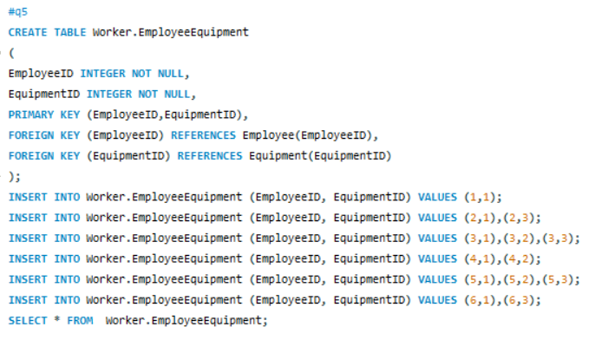

We are writing a code for junction entity between Employee and Equipment tables.

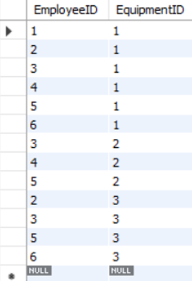

Above is the table of junction entity as Employee id and Equipment id.

**Q6. Create the Training table in the Worker database (table must be based on Physical Model Provided in the Assignment folder). (a) Columns, Primary Key (PK), Data Type & length, and NULL/NOT NULL need to be implemented, as provided in the Physical Model. (b) Show the table definition (DDL) that you implemented. (c) Insert the complete set of data provided in the Excel file (uploaded in the Assignment folder) and show the insert statements used. (d) Retrieve the data from the Training table by using the SELECT * statement and order by PK column(s). Show the output. Make sure you show the print screen of the complete set of the rows and columns. The rows must be ordered by PK column(s).**

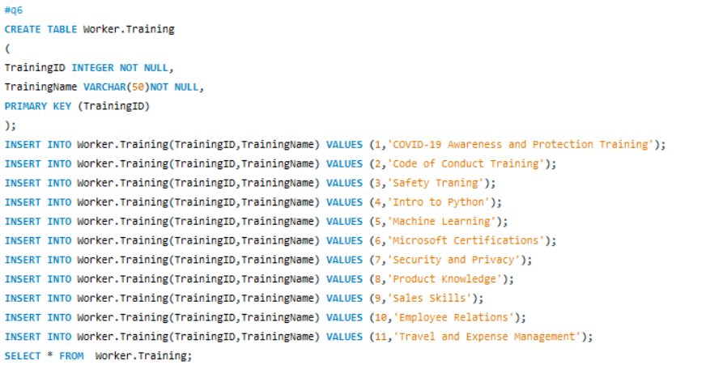

The above code represents the training table creation such as training id and training name.

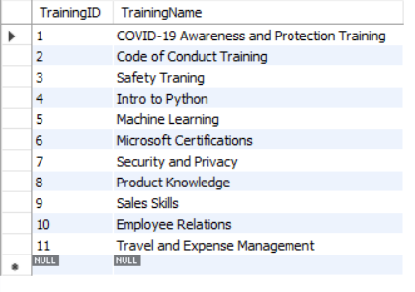

The table represents the training id and training name of the training given in the organisation.

**Q7. Create the EmployeeTraining table in the Worker database (table must be based on Physical Model Provided in the Assignment folder). (a) Columns, Primary Key (PK), Data Type & length, and NULL/NOT NULL need to be implemented, as provided in the Physical Model. (b) Show the table definition (DDL) that you implemented. (c) Insert the complete set of data provided in the Excel file (uploaded in the Assignment folder) and show the insert statements used. (d) Retrieve the data from the EmployeeTraining table by using the SELECT * statement and order by PK column(s). Show the output. Make sure you show the print screen of the complete set of the rows and columns. The rows must be ordered by PK column(s).**

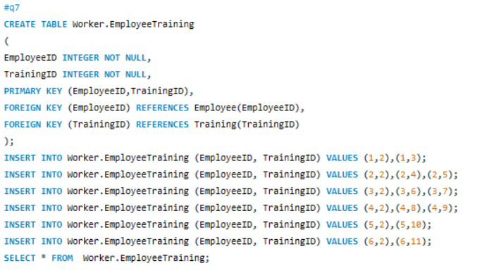

As we are creating a junction entity for the Employee table and Training table.

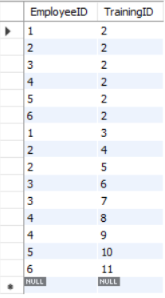

The table represents the Employee and Training ID.

**Q8. Create the Trainer table in the Worker database (table must be based on Physical Model Provided in the Assignment folder). (a) Columns, Primary Key (PK), Data Type & length, and NULL/NOT NULL need to be implemented, as provided in the Physical Model. (b) Show the table definition (DDL) that you implemented. (c) Insert the complete set of data provided in the Excel file (uploaded in the Assignment folder) and show the insert statements used. (d) Retrieve the data from the Trainer table by using the SELECT * statement and order by PK column(s). Show the output. Make sure you show the print screen of the complete set of the rows and columns. The rows must be ordered by PK column(s).**

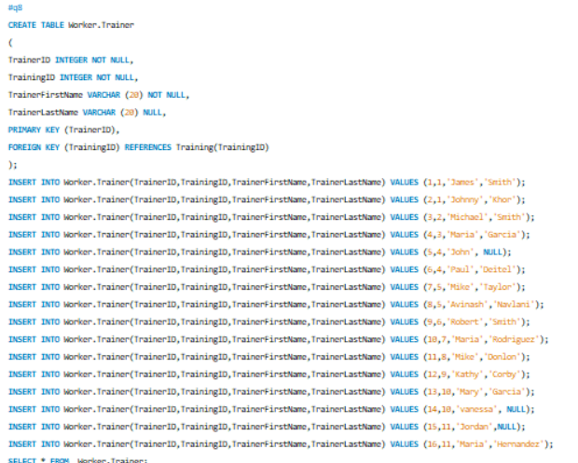

Creating a code for the table of the Trainers.

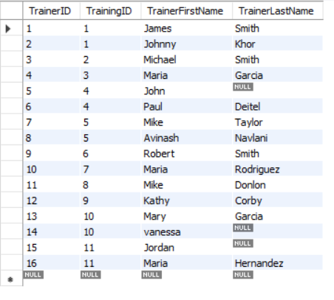

The trainer table looks as above.

**Q9. Retrieve the data from the Trainer table by using the SELECT * statement with filter, WHERE TrainerLastName IS NULL. Show the output. Make sure you show the print screen of the complete set of the rows and columns. The rows must be ordered by PK column(s).**

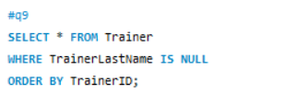

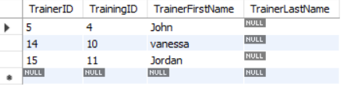

John, Vanessa and Jordan doesn’t have the last name.

**Q10. By using the SHOW tables statements, show the list of tables you have created in the Worker database. Show the screenshot of the execution of the above statements and results. Make sure you show the print screen of the complete set of the rows and columns.**



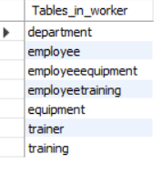

These are the list of tables available in the Worker Database.

**Q11. Write a single-row subquery to display EmployeeID, FirstName, LastName, and HireDate of employees hired after employee Vivek Pandey. Sort the results by EmployeeID. Make sure you show the print screen of the complete set of the rows, and columns as specified.**

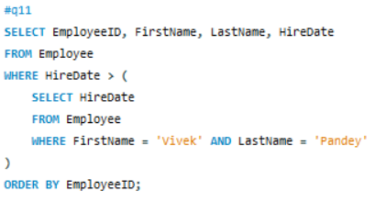

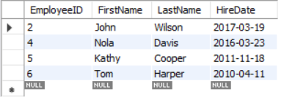

The above table represents the list of employees hired after Vivek Pandey.

**Q12. Write a query to display FirstName, LastName, and TrainingName for employee Tom Harper. Sort the results by TrainingName. Make sure you show the print screen of the complete set of the rows, and columns as specified.**

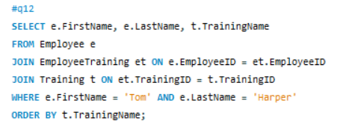

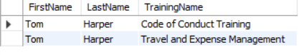

The list of training taken by Tom Harper.

**Q13. Write a query to display the complete list of Trainings, and trainers (first and last name) available for each training. Sort the output by TrainingName and Trainers' first and last name. Make sure you show the print screen of the complete set of the rows, and columns as specified.**

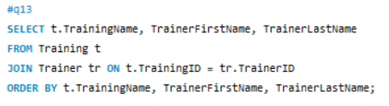

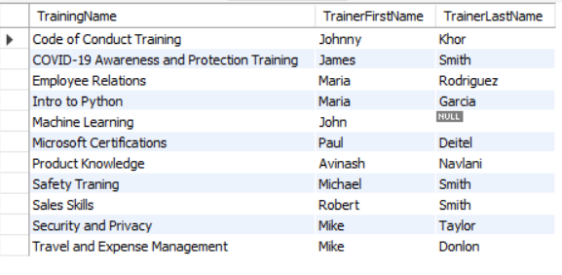

The above is the list of training and trainer provided by the organisation.

**Q14. Write a multiple-row subquery to display EmployeeID, FirstName, LastName, and HireDate of employees who work for the following departments: Accounting and Finance, IT Support, and Production. Sort the results by EmployeeID. Make sure you show the print screen of the complete set of the rows, and columns as specified.**

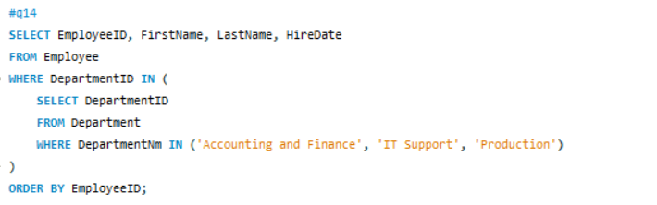

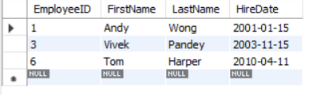

The list of employee who work in Accounting and Finance, IT Support and Production are as displayed above.

**Q15. Write a query to display the EmployeeID, FirstName, LastName, EquipmentName, and EquipmentCostAmount for one of the employees. Sort the results by EmployeeID. Make sure you show the print screen of the complete set of the rows, and columns as specified.**

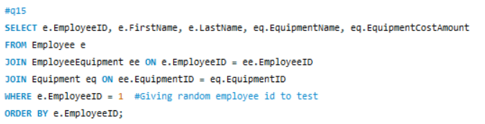



Here we are giving the random employee Id as 1 and the results are displayed as follows for the specified employee.

**Q16. Write a query to display the TrainingID, TrainingName, TrainerID, TrainerFirstName, and TrainerLastName with the trainers who did not provide their last name. Sort the results by TrainingID and TrainerID. Make sure you show the print screen of the complete set of the rows, and columns as specified.**

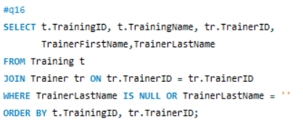

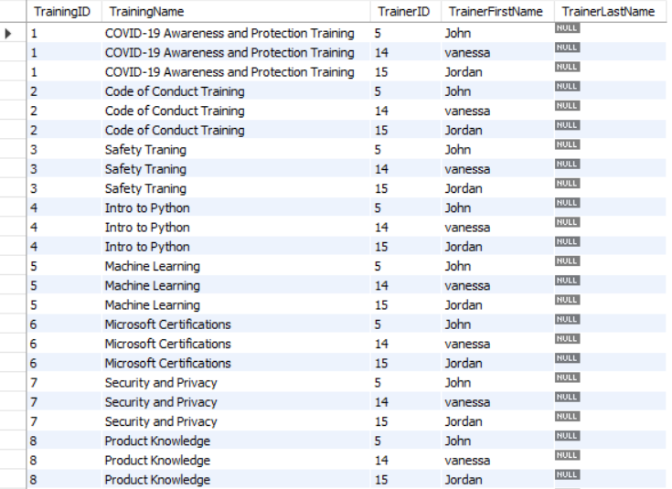

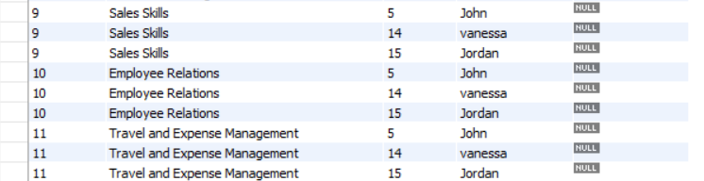

The list of training given by the trainer who doesn’t have last name are as above.

**Q17. Write a query to display the distinct list of equipments used by the current employees. Sort the output by EquipmentName. Make sure you show the print screen of the complete set of the rows, and columns as specified.**

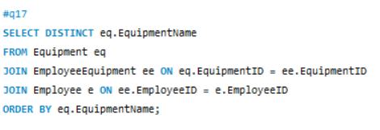

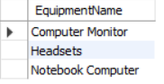

The list of equipment used by current employees in the organisation are as above.

**Q18. Write a query to display the FirstName, LastName, TrainingName, and trainer(s) (with first and last name in two separate columns) for one of the employees. Sort the results by TrainingName and TrainerFirstName. Make sure you show the print screen of the complete set of the rows, and columns as specified.**

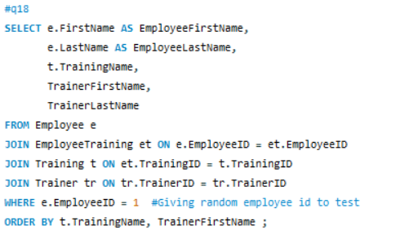

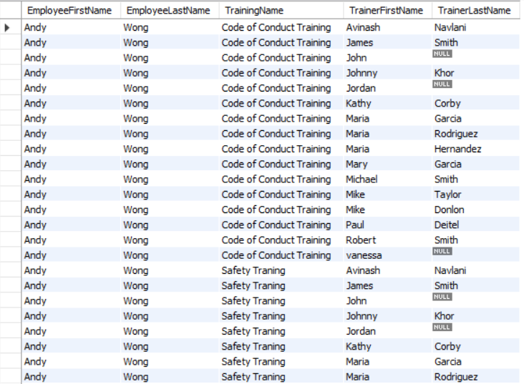

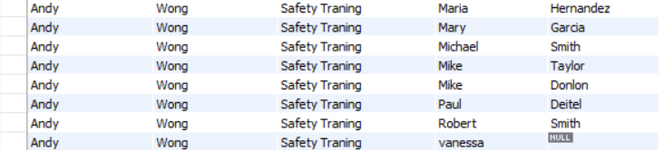

Here we are taking a random employee id as 1 and list of training and trainer with respect to it.

**Q19. Write a query to display the EmployeeID, FirstName, LastName, DepartmentID, DepartmentName, EquipmentID, EquipmentName for all employees. Sort the results by EmployeeID, DepartmentID, and EquipmentID. Make sure you show the print screen of the complete set of the rows, and columns as specified.**

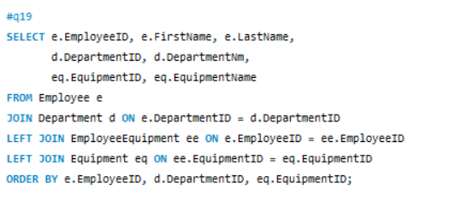

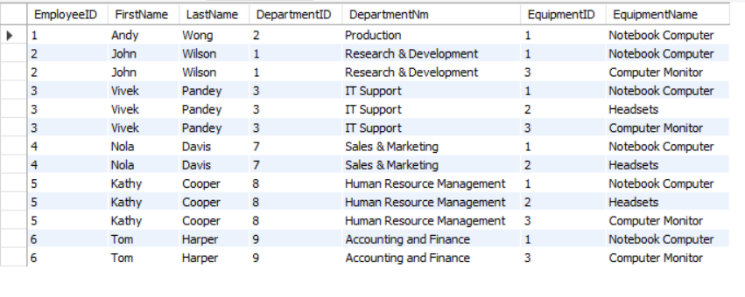

List of equipment used by all the employee with respect to their department are displayed as above.

**20. Write a query to display the EmployeeID, FirstName, LastName, DepartmentID, DepartmentName, TrainingID, TrainingName for all employees. Sort the results by EmployeeID, DepartmentID, and TrainingID. Make sure you show the print screen of the complete set of the rows, and columns as specified.**

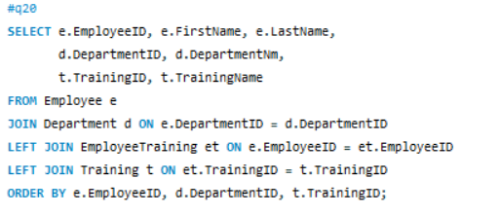

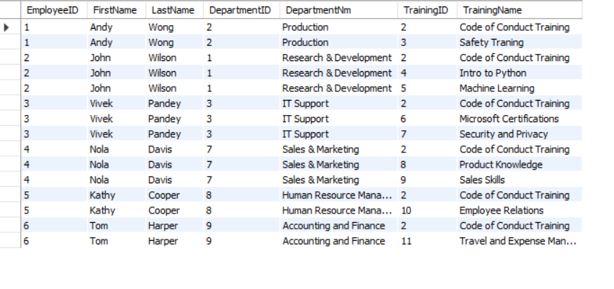

List of Training for all the employee with respect to the Department.